**Berkley First School/ School Development Plan**

**September 2023-24**

**An integrated framework for continued improvement**:

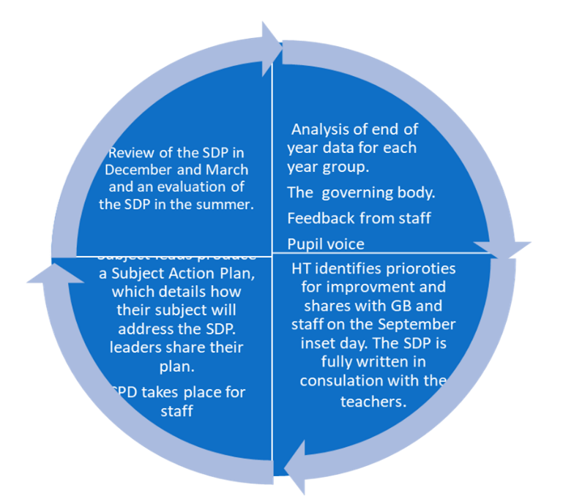

**POSITION:** **2023**

**Since 2019 there has been a significant period of development: growing staff and leaders to meet the changing demands of our educational landscape. The head has worked closely with the Governors in creating a strategic plan for the school. The Head and governors set out their strategic direction for the school and this builds on the development/improvement plan. The Governors fully support the head in ensuring its sustainability and are a strong group.**

**We are a rural setting, on the outskirts of a town, with no immediate community or hamlet so we are a school of choice, as parents have to drive to reach us.**

**Key Barriers: We are a small rural school with little funding. We have cohorts with a range of personal, emotional and social needs. The Head and Governors had to have a full restructure to ensure the financial stability of the school in 2021. In 2022, there were staff changes and new members have joined the team this September.**

**.**

The Appraisal process for staff will address issues relevant to SDP and Pupil Premium children. As far as possible, the objectives within the action plan are measurable, making evaluation straightforward and precise. Our annual Equality policy is included within this SDP.

**AIMS**

* **To strive to be an outstanding school where all stakeholders work together**
* **To provide a happy, caring and secure learning environment where everyone thrives through feeling safe, confident and valued and the wellbeing of each and every individual is a priority.**
* **To nurture children to show respect, consideration and responsibility for others and their environment at all times, both within the school and the wider community.**
* **To support children in becoming independent thinkers and learners.**
* **To aim for excellence across the curriculum.**

**.**

**PRIORITES FOR SCHOOL IMPROVEMENT 2023-24**

|  |  |  |  |  |
| --- | --- | --- | --- | --- |
| **Quality of Education** | **Leadership & Management** | **Partnerships** | **Behaviour & Attitudes** | **Personal Development** |
| **To further, enhance the delivery of English so that more pupils in Year 2, 3 and 4 reach or exceed the ARE.**  **To complete our mastery journey in Maths enabling all pupils to access the new resources and teaching techniques.**  **Monitoring of our subjects** | Create a SEND provision map enabling us to monitor and close the gap.  Introduce our new SENDCO to the community, offering parent surgeries.  New induction for 3 members of staff.  Further, refine teaching pedagogy so that all opportunities are maximised for our GD pupils. | ARTSMARK- New staff to contact the project.  Sewlood Middle School Allow staff to attend CPD offerings.  Explore and use the Secret Garden in the Berkley Estate | **Increase pupils understanding of how to manage emotions when faced with change.** | ECT- Support in 2nd Year  Offer off site experiences to develop the mental health and wellbeing in our pupils.  Staff CPD to include GDPR and E safety updates. |

|  |  |  |  |  |  |  |
| --- | --- | --- | --- | --- | --- | --- |
| **Quality of Education**  *We will inspire all children to reach their full potential across the curriculum. We will encourage and develop their ability to be independent thinkers and learners* | | **Context:**  We have made great progress in regards to intent, implementation and impact. Last year all staff had training to deepen their understanding of how we intend to implement our curriculum and this year we are working on recording the impact. We have experienced staff and our teachers are passionate and driven. | | | | |
| **To improve further our excellent provision we need to:** | **Actions or Tasks** | | **Start**  **Term 1-6** | **Lead** | **Cost** | **Monitoring**  **GOVs** |
| 1, Deepen pupils understanding of maths particularly looking at the greater depth and continue to develop competent and confident mathematicians. | Complete our second year of the Maths Mastery Funded Programme.  Release teachers to attend training and meetings.  HT to meet with AW maths specialist  Create a new timetable/system for delivering the maths lessons to single years 2, 3 and 4 utilising the hall for the other pupils and the TA’s. Review and adjust as necessary.  Funded project- Mastery Number – Delivered in 15 minute sessions.  Develop your classroom practice and pedagogy with professional development for new staff. | | SA and ST and all teachers. | Supply  £500 | Staff feedback  Lesson observations SA and ST  Link Governor- Meet with the leads  Class visits  Conduct Pupil interviews  Book scrutiny to be completed  Compare summer assessments |

|  |  |  |  |  |  |
| --- | --- | --- | --- | --- | --- |
| Adapt the planning and delivery of our writing and oracy lessons across the school to sequence the range of books studied.  Robust systems for monitoring the quality of education across the school are fully in embedded. | New Literacy lead now in place  Purchase an English planning tool across the school from a company called Literacy Tree  Map the books needed and purchase any in the programme.  Coordinators to lead staff in planning high-quality new units of work, where necessary.  Subject co-ordinators to ensure that pupil voice is an integral part of their subject monitoring.  Buy a new RE scheme of work to enhance the delivery.  Whole school work sampling for every subject to take place in Nov and May.  ½ termly meetings with Curriculum Ambassadors to ensure pupil voice is used to help develop the curriculum. | Term 2-6 | JC | £1500  £500 | Staff feedback  Learning walks from Literacy lead- Feedback to staff  Lesson observations  Link Governor- Meet with the Literacy Lead Term 2 and Term 5  Conduct Pupil interview  Book scrutiny to be completed with LL and governor x 2  Assessment data  Heads Reports |
| **IMPACT Term 2** | **IMPACT Spring** | **Summer Evaluation** | | | |
|  |  |  | | | |

Leadership: All leaders including governors are highly ambitious for the schools and lead by example. There is a strong emphasis on distributive leadership, with clearly defined roles for members of the SLT and curriculum leaders, to collectively support teachers in order to ensure pupil outcomes remain ambitious. Staff at all levels have extensive opportunities to apply and extend their expertise and work as a team to contribute to the leadership of the school

This year at Berkley we have 3 new members join our team. All staff at Berkley are passionate about ways to reflect and further improve their teaching.

|  |  |  |  |  |  |  |  |  |  |  |  |  |  |  |
| --- | --- | --- | --- | --- | --- | --- | --- | --- | --- | --- | --- | --- | --- | --- |
| **Leadership & Management**  All leaders and the Governors are highly ambitious for the school and lead by example.  We will inspire all children to reach their full potential in all areas of their life.  .  To ensure a positive and supportive ethos permeates through all aspects of school life ensuring we all celebrate our successes together. | | | | | | | | | | | **Success Criteria**  All stakeholders know what the school is working to achieve and they understand their role in this. They are regularly updated in the school’s progress towards its goals.  Staff's wellbeing is a priority, staff fully understand our vision and aims in school. | | | |
| **Strategy** | | **Actions/Tasks** | | | | | |  |  | **Lead** | **Cost** | | | **Monitoring** |
| Drive forward the outstanding SEN provision by evaluating the existing structure and bringing in additional resources for the mental health of our pupils. | | Induction for new SENDCo- Identify and organise essential training needs in line with the needs of the pupils.  Create a new SEND provision map with our new SENDCo  Purchase new assessment tools for the SEN team to use with the pupils recommended by our new SENDco. | | | | | |  |  | RW | £1000 SEN  Training needs and assessment tools  £1000 Resources + EAL  Boxall £150  £150 | | | Feedback from SENDco  Summer evaluations  Long term plans  ARE pupil assessments  Alternative Provision reports |
| Further, refine teaching pedagogy so that all opportunities are maximised. | | CPD- Researched based teaching – Plan an Inset day  Explore knowledge retrieval within our curriculum | | | | | |  | ST | £600 | | | Professional discussions  Learning journals (floor books)  Pupils work:  History  Georgrpahy  Art and Science  Planning for 2024-25 |
| **Online safety**  For children, parents, staff and governors to have a deeper awareness of current online dangers and know how to keep safe. | | To provide updates for parents, staff and governors on the changes to keeping children safe in Education 2023.  To appoint pupil digital e leaders to develop pupil voice around online habits and ways to stay safe. (E safety group)  Use the 360 tool to assess where we sit as a school, JH to feed this back to ST and SA to make any actions. | | | | | |  |  | Link JH  ST and SA | Over time paid  £250 | | | Link governor meeting to be held in Term 1 with JH.  Meeting with IT for filtering and monitoring checks regarding new updates. (Safeguarding)  Monitoring meeting Termly with ST, SA and JH.  Parent feedback  Pupil Feedback.  Log book of incidents |
| **IMPACT Term 2** | | | | | | **IMPACT Spring Term 4** | | | | | **Impact/Evaluation Term 6** | | | |
|  | | | | | |  | | | | |  | | | |
| **Partnerships**  To nurture children to show respect, consideration and responsibility for others and their environment at all times, both within the school and the wider community.  To build on the strong relationship with the church and wider community so that it benefits all children and for this to be celebrated within our Christian ethos. | | | | | | | | | | | **Success Criteria**   1. To be able to comment on collective worship with Rev Ronnie and the ‘open the book community. 2. Children feel part of the Frome community and can comment on how we help others. | | | |
| **Strategy** | **Actions/Tasks** | | | | | | |  | **Timescale** | **Lead** | **Cost** | | **Monitoring** | |
| ARTSMARK  *Opportunities to work with other schools* | Link Governor to put us in touch with schools for JC to visit.  JC to lead an inset day on the use of Sketch books  JC to lead training on assessing drawing in the classroom | | | | | | |  |  | JC | Professional discussions and staff’s feedback  Pupil voice  Sketch books | | | |
| **Collaborative working**  Continue to work collaboratively to make an effective contribution to the wider community in Frome.  Continue to build on the relationship with the church. | Links within Frome and the Art trail.  Winter Wonderland  Following on from last year, we will meet with Caroline White who will lead the family services at the weekends and we will plan in at least 4 events.  Shared collective worship with Beckington School  Collective worship to take place outside in the courtyard.  Carols outside in the evening for all of the community with churchwardens providing drinks.  Older pupils to visit Keyford Educational Foundation. | | | | | | |  | Term 2 | ST and SA | Governor to support ideas of links in the community.  Parent feedback  Pupil Feedback.  School council notes  Newsletters | | | |
| **Progress Term 2** | | | | **Progress Term 4** | | | | | | | **Impact/Evaluation Term 6** | | | |
|  | | | |  | | | | | | |  | | | |
| **Personal Development,**  **For all children to be the best they can be, to be able to reflect on their own learning, their behaviour, beliefs and emotional needs.** | | | | | | | | | | **Success Criteria**   1. Children are ready to learn as their emotional needs have been met. 2. Children are well behaved at all times. 3. Children make healthy choices 4. Children understand how to reflect. | | | | |
| Strategy | **Actions or tasks** | | | | | | **Timescale** | | **Lead** | **Cost** | | **Monitoring** | | |
| Pupils to be courageous advocates | Pupils to start the ARTs committee again with JC as the new lead in Term 2  Begin to link with new partnerships in Frome to enable us to strengthen our relationships with charities.  Develop their understanding of how they can make a difference and raise awareness of worldwide issues.  SIAMS committee to add to their action plan this year. | | | | | | Term 2-6 | |  | £300 | | SIAM’s committee minutes and feedback.  Heads Report to Governors | | |
| **IMPACT Term 2** | | | | | **IMPACT Term 4** | | | | | **Impact/Evaluation Term** | | | | |
| **Personal Development: We aim to ensure our pupils are developing deep resilience in all aspects of the curriculum and life. We want them to develop independence in their learning and the confidence to test themselves in unfamiliar areas. We are mindful of the physical and mental wellbeing of the pupils and tailor the opportunities both within the school day and outside of this to meet.** | | | | | | | | | | | | | | |
| **Behaviour and Attitudes**  To provide a happy, caring and secure learning environment where everyone thrives through feeling safe, confident and valued and the wellbeing of each and every individual is a priority | | | | | | | **Success Criteria**  Pupils are confident to talk about their learning and their feelings and beliefs.  Staff, pupils and the community now we put well- being at the heart of all we do. | | | | | | | |
| **Objective:** | **Actions** | | | | | | **Timescale** | | **Lead** | **Cost** | | **Monitoring** | | |
| Improve our offering within the playground where it is hard ground and on the field to extend imaginative play. | Purchase through fundraising a wooden adventure structure that promotes creativity and imagination.  Using a section of the field make a forest/area of magical imagination for the pupils to use. (as a school community)  Storytelling, den making, forest skills, imaginative play with a shelter. | | | | | |  | | All | £1,500  £400 | | Pupil feedback  Observation of playtime by staff  Staff discussions  FBS group | | |
| Enrich the pupils experience when travelling around the site. | Purchase an outdoor map, put up a historical timeline so pupils can apply their knowledge. | | | | | |  | |  | £600 | | Has this made a positive impact on the learning of these subjects?  Knowledge gathered. | | |
| **Progress Term 2** | | | | | | | **Progress Term 4** | | | **Impact/Evaluation Term 6** | | | | |
|  | | |  | | | | | | |  | | | | |