Berkley First School
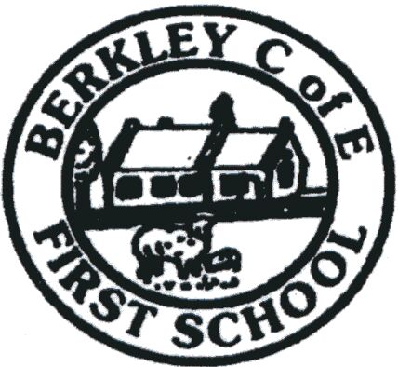

How we teach calculations:
Calculation Policy for
Mathematics

September 2022

Our vision and values
We are a small school, with big ideas, adopting a creative approach to ensure that every child is supported in order to flourish and thrive; to see and develop their true potential.

Our vision and ethos of the school is based on the sermon of the mount, Matthew 5:14- 16; “You are the light that gives light to the world. In the same way, let your light shine before others, live so that they may see your good works.”

We are children of the community and guided by Faith.

About our Calculation Policy

The following calculation policy has been devised to meet requirements of the National Curriculum 2014 for the teaching and learning of mathematics, and is also designed to give pupils a consistent and smooth progression of learning in calculations across the school. Please note that early learning in number and calculation in Reception follows the ‘Development Matters’‛ EYFS document, and this calculation policy is designed to build on progressively from the content and methods established in the Early Years Foundation Stage. The policy has been designed to teach children through the use of concrete, pictorial and abstract methods and supports children in developing a deep understanding of number and calculation.

Using the concrete/pictorial/abstract approach

This approach helps children to learn new ideas and build on their existing knowledge by introducing abstract concepts in a more familiar and tangible way. Reinforcement is achieved by moving back and forth between these representations.

Concrete - Concrete is the “doing” stage, using concrete objects to model problems. This will be done using a range of resources.

Pictorial - Pictorial is the “seeing” stage, using representations of the objects to model problems. This stage encourages children to make a mental connection between the physical object and abstract levels of understanding by drawing or looking at pictures, circles, diagrams or models which represent the objects in the problem.

Abstract - Abstract is the “symbolic” stage, where children are able to use abstract symbols to model problems. Only once a child has demonstrated that they have a solid understanding of the “concrete” and “pictorial” representations of the problem, can the teacher introduce the more “abstract” concept, such as mathematical symbols. Children are introduced to the concept at a symbolic level, using only numbers, notation, and mathematical symbols, for example +, –, x, / to indicate addition, multiplication, or division.

At Berkley School we use the White Rose Learning Hub scheme of work as part of our long and medium term planning and use this calculation policy alongside other resources and strategies to meet the needs of our children and the curriculum. The policy outlines strategies and teachers will plan opportunities for children to apply these.

Reviewed Autumn 2022
Next review: Summer 2024

