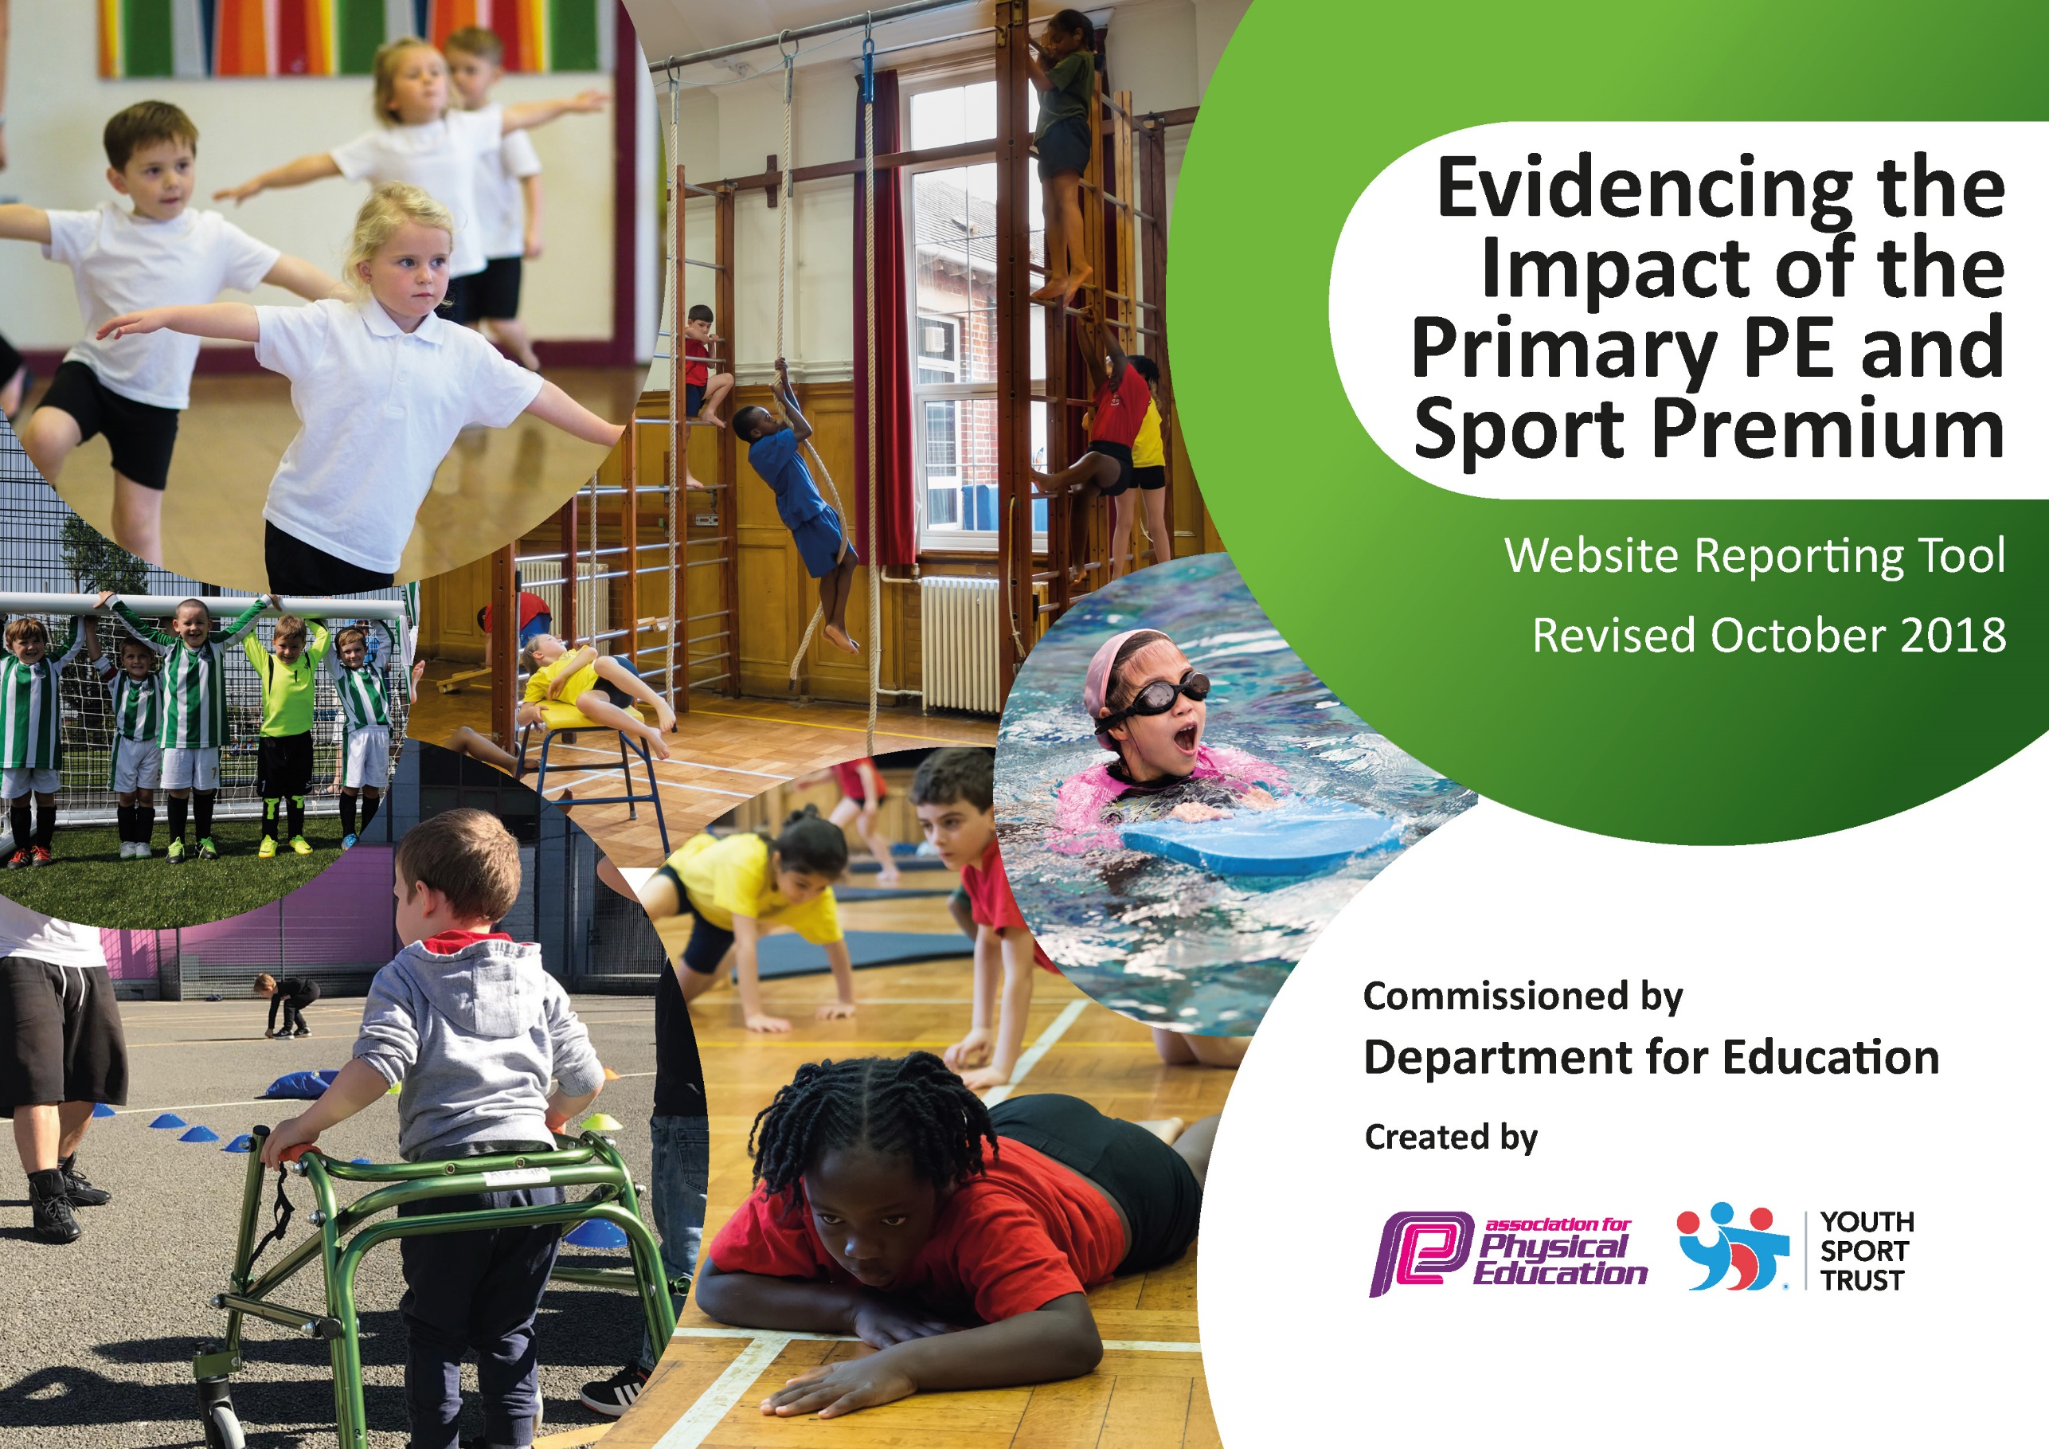
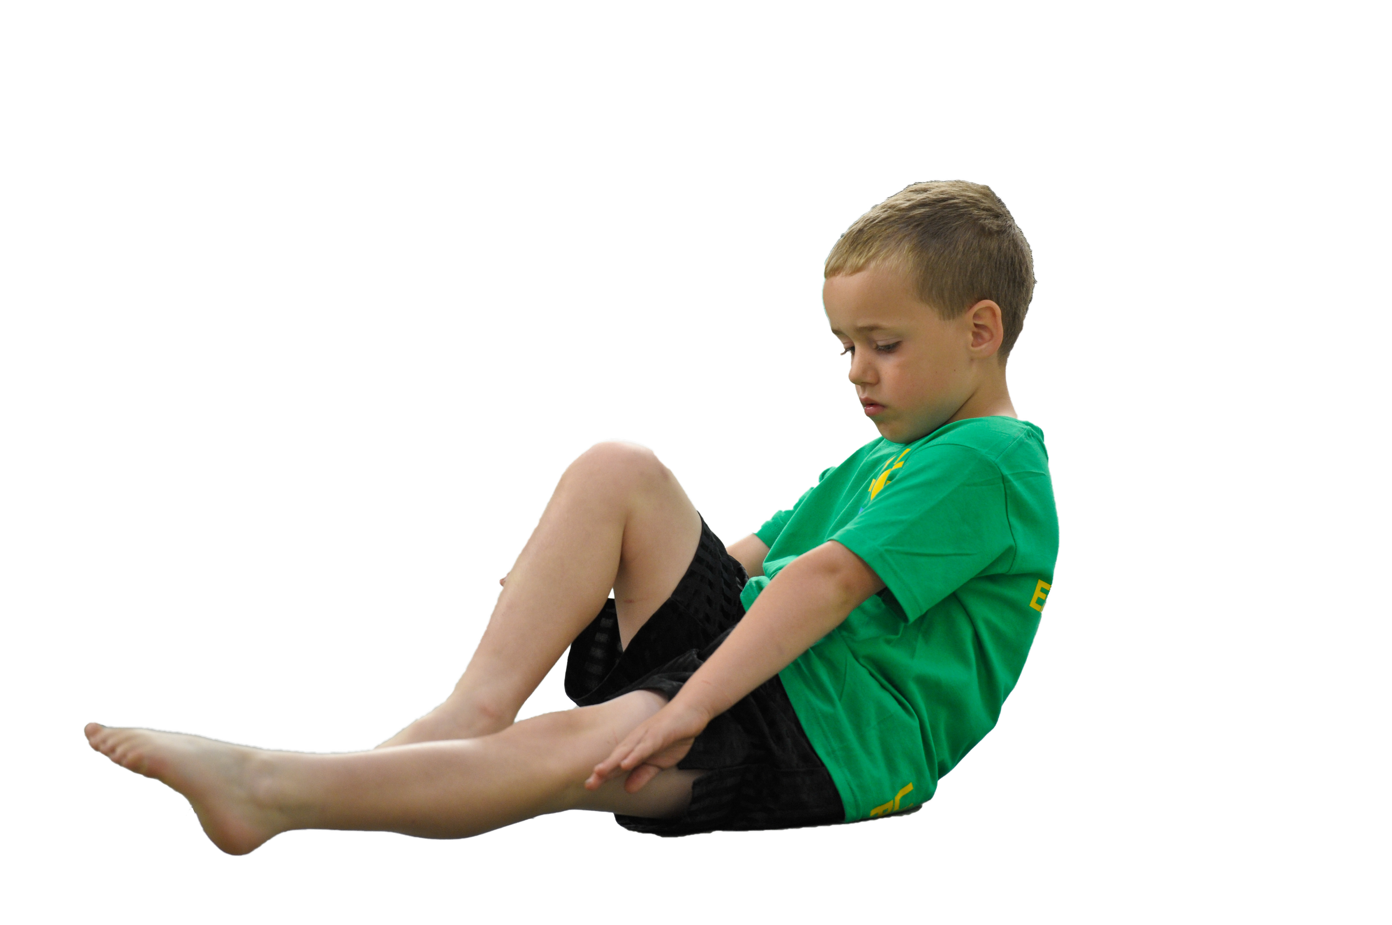
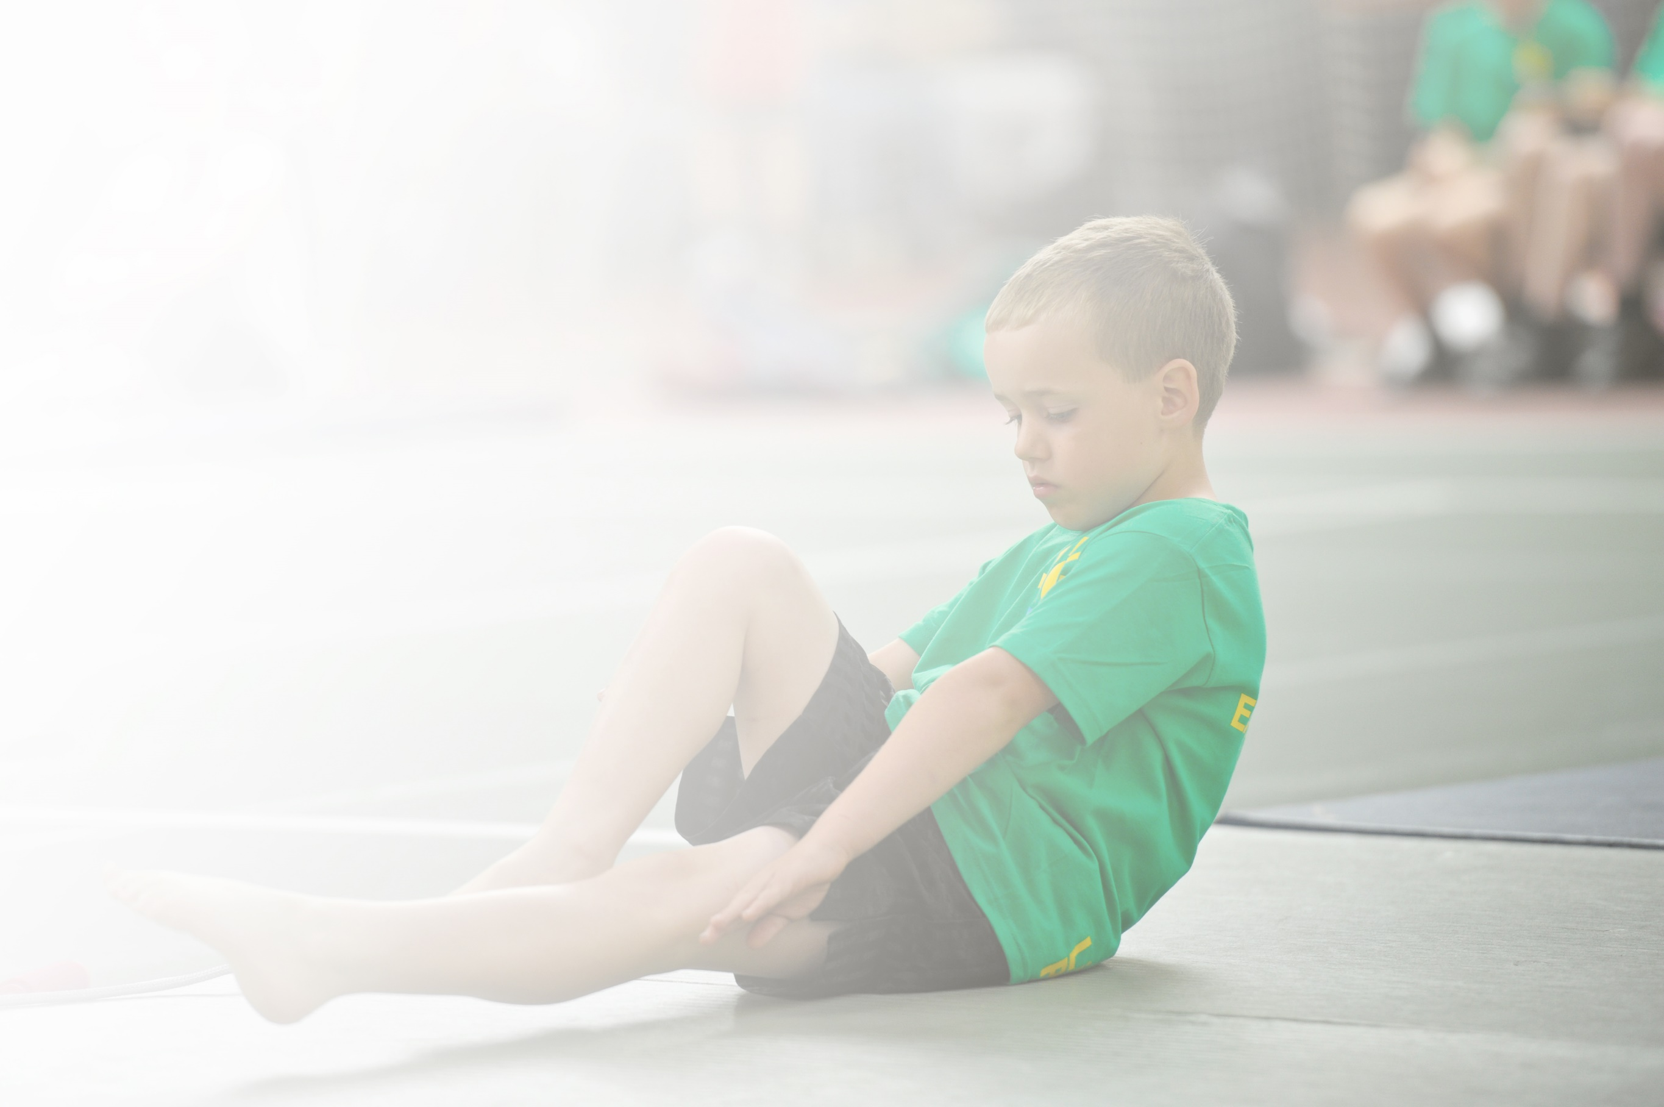
Schools must use the funding to make additional and sustainable improvements to the quality of Physical Education, Sport and Physical Activity (PESPA) they offer. This means that you should use the Primary PE and Sport Premium to:

- Develop or add to the PESPA activities that your school already offer
- Build capacity and capability within the school to ensure that improvements made now will benefit pupils joining the school in future years

Please visit gov.uk for the revised DfE guidance including the 5 key indicators across which schools should demonstrate an improvement. This document will help you to review your provision and to report
your spend. DfE encourages schools to use this template as an effective way of meeting the reporting requirements of the Primary PE and Sport Premium.

We recommend you start by reflecting on the impact of current provision and reviewing the previous
spend. Under the Ofsted Schools Inspection Framework, inspectors will assess how effectively leaders use the Primary PE and Sport Premium and measure its impact on outcomes for pupils, and how effectively governors hold them to account for this.

Schools are required to publish details of how they spend this funding as well as on the impact it has on pupils’ PE and sport participation and attainment by the end of the summer term or by 31 July 2019 at the
latest.
We recommend regularly updating the table and publishing it
on your website throughout the year, as evidence of your
ongoing review into how you are using the money to
secure maximum, sustainable impact. To see an
example of how to complete the table please
click HERE.

Support for review and reflection - considering the 5 key indicators from DfE, what development needs are a priority for your setting and your students now and why? Use the space below to reflect on previous spend, identify current need and priorities for the future.

Key achievements to date: | Areas for further improvement and baseline evidence of need:
We have continued to have staff members observe coaching staff and this has improved confidence of teaching staff and allowed them to deliver lessons in order to reinforce learning.  The profile of sport in our school has increased and children are engaged with the wide opportunities available to them. This year there were further opportunities to engage – including a dance festival.  Each year group has participated in a festival alongside other schools.  IG coaching staff continue to have a positive influence at lunchtimes, with children playing a variety of games and being active.  Playtime leaders have been trained by Lynne Langton and they have been delivering a variety of activities during breaktimes. Therefore, there are planned activities available breaktime and lunchtime for the entire school. The year 4’s have shown tremendous leadership during their sessions and this will support their transition to middle school.  Swimming lessons at Frome Leisure Centre have been a success, with Years 1 – 4 all taking part in a weekly 30 minute swimming lesson. (KS1 and KS2 rotated half-termly)  Unfortunately many of the festivals we were due to take part in were cancelled due to Covid-19. We were on track to compete in as many festivals as last year which would have been a triumph considering we were unable to obtain transport at the beginning of the year.  A new noticeboard that is updated regularly to show recent festivals, upcoming festivals and sport in the wider world. | It would still be beneficial for all members of staff to observe and support coaching staff as well as take part in some form of sporting CPD i.e. cricket training.  Organise the race for life that we were unable to do in May due to Covid-19. It would be great to take part in a sponsored event that engages the wider community.  Evidencing the positive effects that sport has on the mental health of our children.  Improving the playground facility to allow more sport to take place.  Evidence working with children and parents to make healthier choices within their lunchboxes.  To continue to increase participation in more competitive sport and starting a small football league.  To organise a new scheme of work that focuses on more social skills as well as movement. The new scheme must assess the children in this.

Meeting national curriculum requirements for swimming and water safety | Please complete all of the below:
What percentage of your current Year 6 cohort swim competently, confidently and proficiently over a distance of at least 25 metres?  N.B. Even though your children may swim in another year please report on their attainment on leaving  primary school. | %
What percentage of your current Year 6 cohort use a range of strokes effectively [for example, front crawl, backstroke and breaststroke]? | %
What percentage of your current Year 6 cohort perform safe self-rescue in different water-based situations? | %
Schools can choose to use the Primary PE and Sport Premium to provide additional provision for swimming but this must be for activity over and above the national curriculum requirements. Have you used it in this way? | Yes/No
UNABLE TO COMPLETE THIS DUE TO COVID-19. SWIMMING DID NOT TAKE PLACE.

Action Plan and Budget Tracking
Capture your intended annual spend against the 5 key indicators. Clarify the success criteria and evidence of impact that you intend to measure to evaluate for students today and for the future.

Academic Year: 2020/21 | Total fund allocated: £16,750 | Date Updated: April 2020
Key indicator 1: The engagement of all pupils in regular physical activity – Chief Medical Officer guidelines recommend that primary school children undertake at least 30 minutes of physical activity a day in school |  |  |  | Percentage of total allocation:
 |  |  |  | %
School focus with clarity on intended impact on pupils: | Actions to achieve: | Funding allocated: | Evidence and impact: | Sustainability and suggested next steps:
Ensure all staff and children do daily wake and shake in all 4 classes across the school  Introduce more equipment to playtimes  Continue with the daily mile (active mile)  Take part in a ‘Race for life’  Field marking  Medals for sports day  Continued use of lunchtime play staff  Breakfast club, after school clubs  Home PE lessons | Staff to follow and add to document created by GB containing links to activities  GB to find each classes equipment needs and source items.  Sports coaches to complete activity within lessons and lunchtimes  GB has medals from previous application. Organise race for life at the cricket ground once restrictions ease.  Markings for Sport’s Day as well as football matches  LA Grounds  GB to organise  IG Sports  Range of activities to engage ALL children.  Children to follow PE lessons provided by I.G Sports during lockdown | None  £1500  None  None  £50  £100  £12,000  (used in more than one allocation)  Self-funded  £12,000  (used in more than one allocation) | This continues to be a success across the school. With the removal of singing (Covid) children were still able to enjoy dancing each day.  GB researched a range a of sports equipment packages. GB organised each classroom to have their own PE box that has enough equipment to fulfil their curriculum needs. Each box has its own equipment list that must be audited regularly by the class teacher.  Children still enjoy this activity and continues to be successful.  Restrictions didn’t ease enough to make this possible yet.  Sports Day was a tremendous success with each class having their individual events.  We continue to order medals from the same company as they are reasonably priced and good quality.  Lunchtime provision continues to be a success as sports coaches continue to support children with games. There is the opportunity for children to play football freely. There are a variety of games to encourage physical activity.  Through IG Sports, these continue to be successful. Archery was introduced this year.  IG Sports was available to teach live lessons throughout the lockdown. He taught practical activities with pupils finding equipment they could use in their homes e.g. a rolled up pair of socks. | Source a new scheme of work that has resources and planning for dance.  Any equipment that is accidently broken or lost can be replaced by the request of class teacher. The class teacher can also request equipment for other sporting initiatives.  Children can have a ‘daily mile diary’ where they record their experiences of the mile.  This will take part next year.  We will continue this.  We will continue this.  We will meet regularly to discuss the impact of the games.  A pupil and parent survey to see if there are any other opportunities they would like offered to them.  PE returned to face-to-face.
Key indicator 2: The profile of PESSPA being raised across the school as a tool for whole school improvement |  |  |  | Percentage of total allocation:
 |  |  |  | %
School focus with clarity on intended impact on pupils: | Actions to achieve: | Funding allocated: | Evidence and impact: | Sustainability and suggested next steps:
To keep up to date with latest developments  PESP report to be published on the website by | FLP/PLT meetings (Termly meetings =3  Organising events throughout the year – Rugby, cricket, gymnastics, tennis etc.  GB and SBM and IG meet to discuss impact as well as next year’s predicted budget | £1000 | Meetings were cancelled due to Covid. GB met with IG to discuss provision with restrictions. Restrictions slowly eased and face-to-face lessons resumed. Festivals have been taking place within bubbles.  Meeting was successful as it was agreed that we must purchase a new scheme of work to be run across the school. This will be purchased using new year’s budget. | As restrictions ease the meetings will return and so will the events. Online meetings.  This will provide more confidence to class teachers and more importantly the children will be more engaged in PE than ever.

Key indicator 3: Increased confidence, knowledge and skills of all staff in teaching PE and sport |  |  |  | Percentage of total allocation:
 |  |  |  | %
School focus with clarity on intended  impact on pupils: | Actions to achieve: | Funding  allocated: | Evidence and impact: | Sustainability and suggested  next steps:
To improve progress and achievement of all pupils we aim to upskill all of our teaching staff and teaching assistants. In line with the SDP.  Offer opportunities for staff to observe members of teaching staff from other schools  Subject lead to undertake CPD | Observe IG Sports (TA and IG Sports)  Somerset Cricket coach to provide training for all staff  4 members of staff to visit other schools in FLP  Continue to develop subject leader in order to impact children as well as staff. | £500  £500 | Staff continue to support during lessons. IG staff also support teaching staff.  Teaching staff and teaching assistants took part in a CPD session after school. Staff learnt a range of activities to be delivered in lessons as well as lunchtimes.  This will happen next year due to Covid  This has been organised after the release of the new budget | Staff to continue this partnership as it is successful.  Staff to introduce cricket more often into the school calendar. The ‘Chance to Shine’ resources are available. We also pay our yearly membership to Somerset Cricket.  SASP will train subject lead.  (Somerset activity and sports partnership)
Key indicator 4: Broader experience of a range of sports and activities offered to all pupils |  |  |  | Percentage of total allocation:
 |  |  |  | %
School focus with clarity on intended  impact on pupils: | Actions to achieve: | Funding  allocated: | Evidence and impact: | Sustainability and suggested  next steps:
Additional achievements:  During PE lessons children will experience a variety of different sports including….  Residential  Forest school  Identify children that require additional support and organise small sessions to increase confidence  Identify gifted and talented and arrange opportunity for small sessions  After school clubs organised by IG sports  Breakfast club organised by IG sports  Cricket coaching  Funtrition (wow sessions) | Tennis  Tag Rugby  Hockey  Archery  Dance  LL to organise  Intervention group – IG sports  Intervention Group – I G Sports  Additional support to ensure all children who have not received breakfast have access to some  Somerset County Cricket  Wow sessions to improve health and wellbeing incl. mental health | £12,000  (used in more than one allocation)  None  £12,000 in more than one location  Self-funded  £30  £1000 | Tennis coach from Frome Tennis Club ran sessions across years 2, 3 and 4. The children were engaged by the session. He offered scholarships to a few of the children. Those children are now part of Frome Tennis Club.  We asked IG sports to review the variety of after school clubs offered. As a result archery was introduced.  Children went daily to Mill on the Brue. They triumphed in a range of physical activities.  This was not achieved this year due to restrictions.  However, provision was needed elsewhere due to staff shortages throughout the pandemic.Berkley employed IG sports to cover staff shortages. This enabled children to benefit through more sporting opportunites  Breakfast club was organised in bubbles. After school clubs were put on hold  Cricket was taught across the school for 6 weeks in the summer term. MW and GB organised a cricket sports day at Frome Cricket Club which ended as a tremendous success.  As a result, many children attended ‘All Stars Cricket’ at weekends.  This wasn’t possible this year due to funding. | Dance is one of the priorities for next year. We aim to take part in a festival like previously if this becomes available again.  This continues to be a great place to go. They offer lots of activities.  We will continue this next year.  These will continue once restrictions ease.  We will continue the partnership with Somerset Cricket and aim for another Cricket Sports Day next year.  GB to include healthy living within new resources for teachers.
Key indicator 5: Increased participation in competitive sport |  |  |  | Percentage of total allocation:
 |  |  |  | %
School focus with clarity on intended  impact on pupils: | Actions to achieve: | Funding  allocated: | Evidence and impact: | Sustainability and suggested  next steps:
Travel costs and use of Rode’s minibus  Clive Lewis tag rugby  Gymnastics SASP  Swimming gala  Dance Festival  FLP membership | Teacher time to organise. Ensure each year group participates in at least one festival. Try to make this as time/cost effective for parents to ensure maximum participation.  Enter as many children as possible from years 3 and 4. Minimum 3 teams of 8. Try to impact girls.  Target relatively keen gymnasts (boys and girls).  Gifted and talented.  A whole class attend festival  Membership to Frome’s partnership allows us entry to all festivals as well as gives us opportunities to discuss recent initiatives. | £500  Incl. as above  Incl. as above  Incl. as above  Incl. As above  £1200 | This is no longer possible due to Rode’s driver not being insured to take other schools.  Cancelled due to Covid  Cancelled due to being unable to source transport  Cancelled due to Covid  Not organised.  Many events cancelled due to Covid-19. The partnership will endeavour to support us greatly next year. This will include more events including a wider variety. | LL to be released to drive Rode’s bus as class teacher is allowed to drive their own school. LL has minibus licence.  We aim to attend next year.  We aim to attend next year.  We aim to attend next year  We aim to attend next year.  We will continue this next year.

