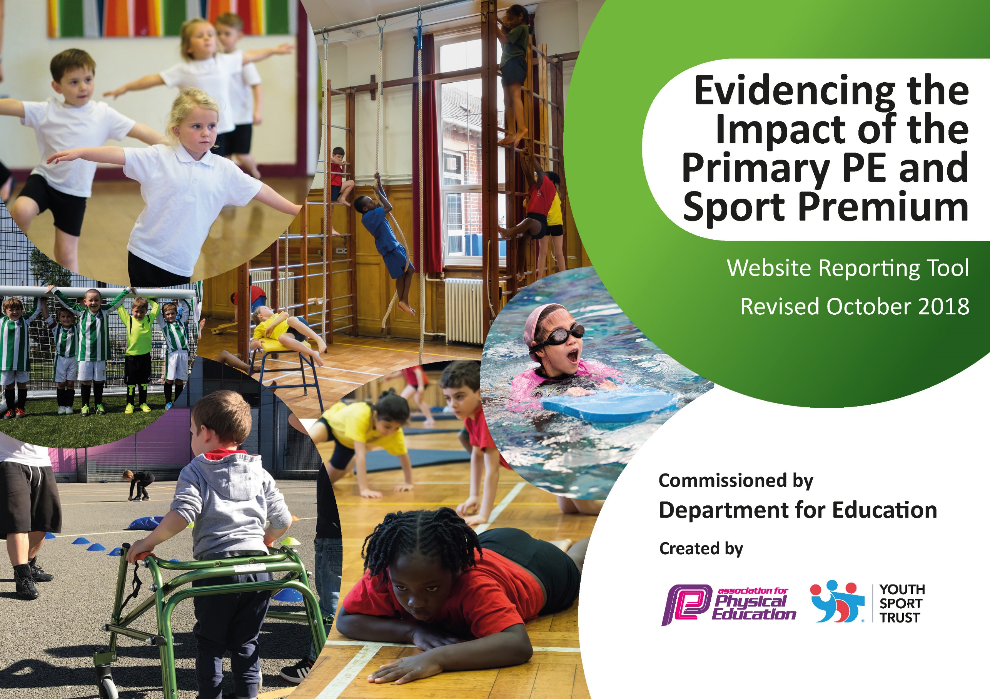
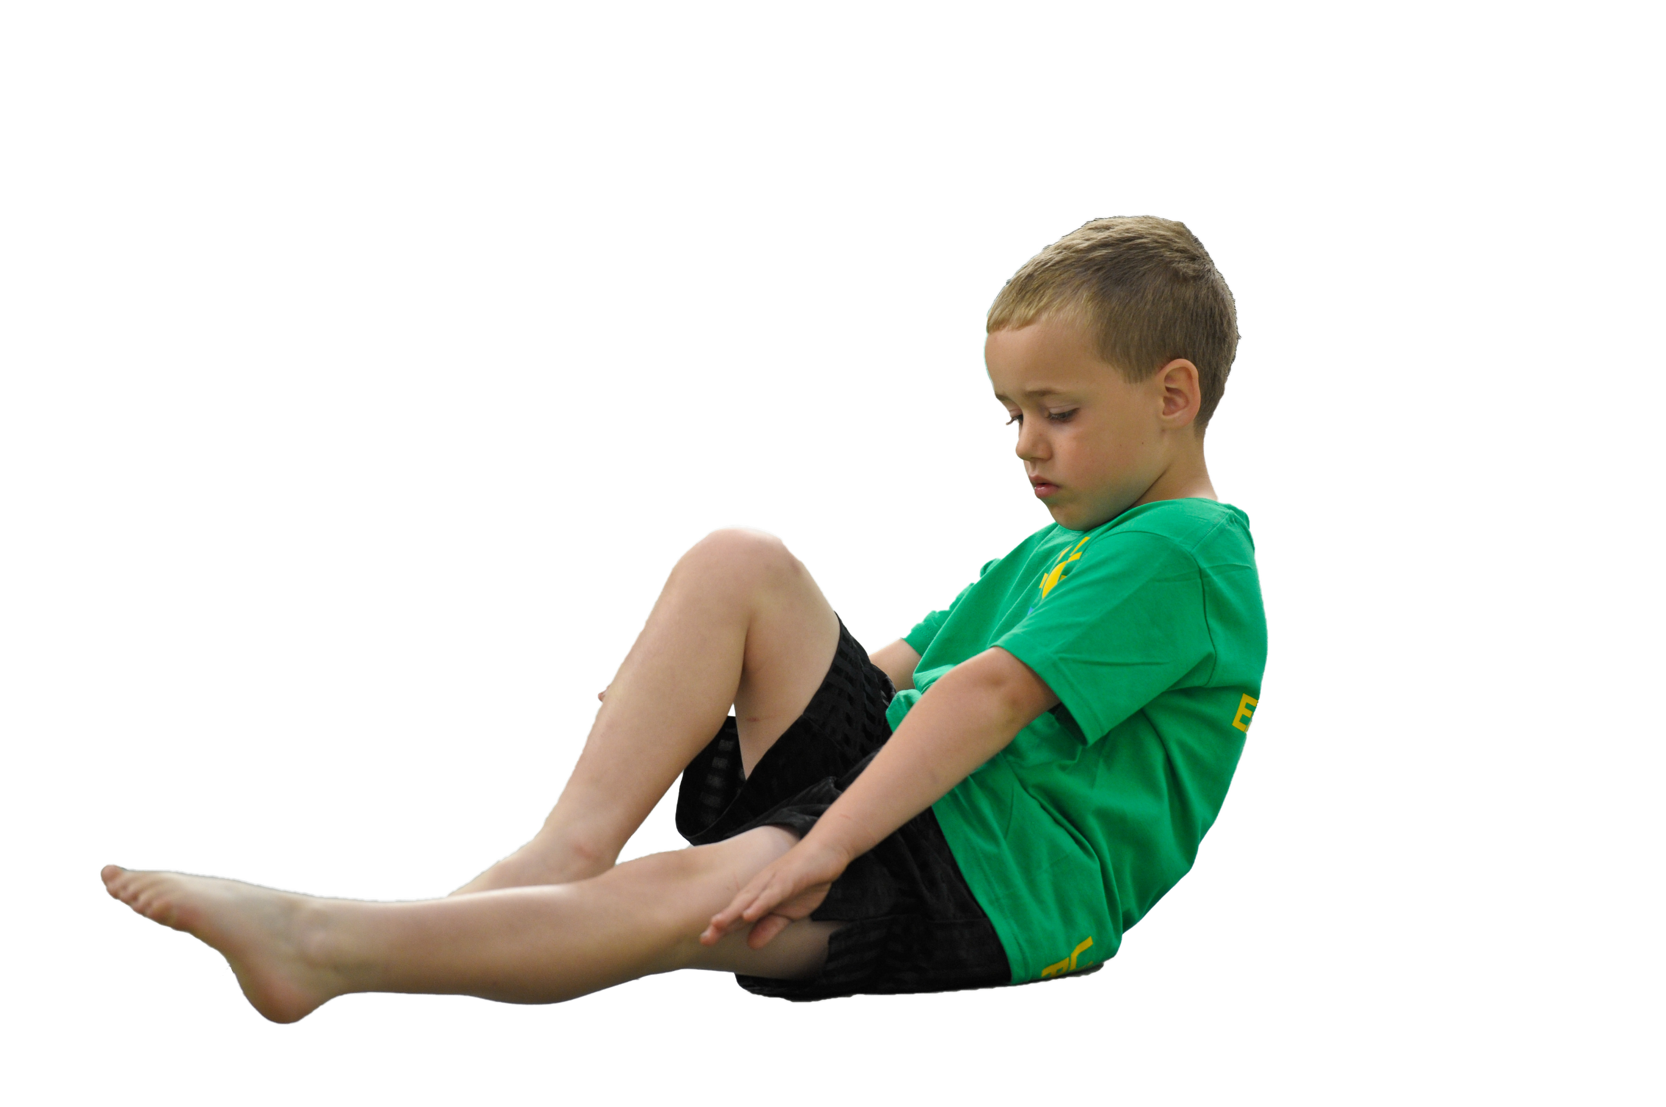
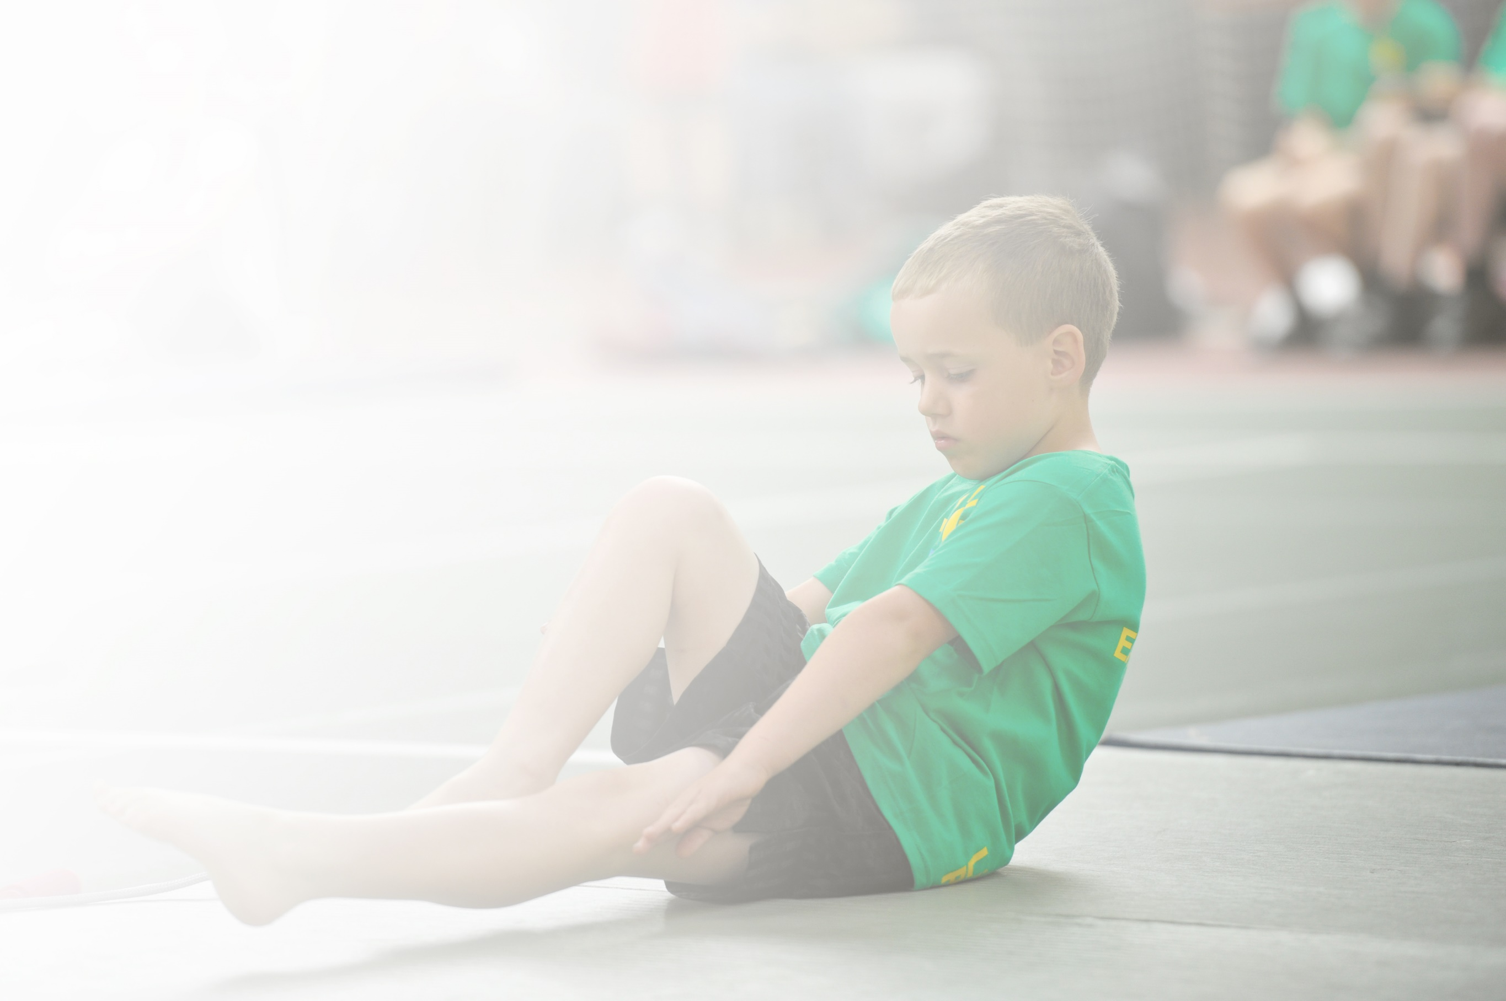
Schools must use the funding to make additional and sustainable improvements to the quality of Physical Education, Sport and Physical Activity (PESPA) they offer. This means that you should use the Primary PE and Sport Premium to:

- Develop or add to the PESPA activities that your school already offer
- Build capacity and capability within the school to ensure that improvements made now will benefit pupils joining the school in future years

Please visit gov.uk for the revised DfE guidance including the 5 key indicators across which schools should demonstrate an improvement. This document will help you to review your provision and to report
your spend. DfE encourages schools to use this template as an effective way of meeting the reporting requirements of the Primary PE and Sport Premium.

We recommend you start by reflecting on the impact of current provision and reviewing the previous
spend. Under the Ofsted Schools Inspection Framework, inspectors will assess how effectively leaders use the Primary PE and Sport Premium and measure its impact on outcomes for pupils, and how effectively governors hold them to account for this.

Schools are required to publish details of how they spend this funding as well as on the impact it has on pupils’ PE and sport participation and attainment by the end of the summer term or by 31 July 2019 at the
latest.
We recommend regularly updating the table and publishing it
on your website throughout the year, as evidence of your
ongoing review into how you are using the money to
secure maximum, sustainable impact. To see an
example of how to complete the table please
click HERE.

Support for review and reflection - considering the 5 key indicators from DfE, what development needs are a priority for your setting and your students now and why? Use the space below to reflect on previous spend, identify current need and priorities for the future.

Key achievements to date: | Areas for further improvement and baseline evidence of need:
Having staff members observe coaching staff has improved confidence of teaching staff and allowed them to deliver lessons in order to reinforce learning.  The profile of sport in our school has increased and children are engaged with the wide opportunities available to them.  Pupils involvement in competitive sport has increased and more children much more willing to take part. We entered 3 teams in the football tournament (one team winning) We entered 3 teams in the rugby tournament (one team winning).  IG coaching staff continue to have a positive influence at lunchtimes, with children playing a variety of games and being active.  Playtime leaders have been trained by IG staff to deliver some of the activities on offer at lunchtimes. The children are demonstrating tremendous leadership qualities. This will also support their transition to middle school.  Swimming lessons at Creative Aquatic have been a success, with Years 1 – 4 all taking part in a weekly 30 minute swimming lesson. (KS1 and KS2 rotate half-termly)  Sports day included a variety of individual sports that were extremely inclusive. Parents were able to see a snapshot of the brilliant opportunities available to their children. | Having recruited a few newer members of staff, it would be beneficial for all members of staff to observe coaching staff as well as take part in some form of sporting CPD i.e. cricket training.  With metal health being such a current focus, we aim to do some work regarding this, not just throughout PHSE.  As obesity is a continuous threat, we aim to do some fun work with the children regarding nutrition, exercise and the importance of good health.  To increase participation in more competitive sport, potentially starting a football league within our small community of schools.

Meeting national curriculum requirements for swimming and water safety | Please complete all of the below:
What percentage of your current Year 6 cohort swim competently, confidently and proficiently over a distance of at least 25 metres?  N.B. Even though your children may swim in another year please report on their attainment on leaving  primary school. | %
What percentage of your current Year 6 cohort use a range of strokes effectively [for example, front crawl, backstroke and breaststroke]? | %
What percentage of your current Year 6 cohort perform safe self-rescue in different water-based situations? | %
Schools can choose to use the Primary PE and Sport Premium to provide additional provision for swimming but this must be for activity over and above the national curriculum requirements. Have you used it in this way? | Yes/No
THIS ASSESSMENT WAS CANCELLED DUE TO COVID-19

Action Plan and Budget Tracking
Capture your intended annual spend against the 5 key indicators. Clarify the success criteria and evidence of impact that you intend to measure to evaluate for students today and for the future.

Academic Year: 2018/19 | Total fund allocated: £16,750 | Date Updated: April 2019
Key indicator 1: The engagement of all pupils in regular physical activity – Chief Medical Officer guidelines recommend that primary school children undertake at least 30 minutes of physical activity a day in school |  |  |  | Percentage of total allocation:
 |  |  |  | %
School focus with clarity on intended impact on pupils: | Actions to achieve: | Funding allocated: | Evidence and impact: | Sustainability and suggested next steps:
Introduce daily wake and shake in all 4 classes across the school  Introduce more equipment to playtimes  Introduce daily mile – run for charity  Take part in sport relief  Field marking  Medals for sports day  Continued use of lunchtime play staff  Breakfast club, after school clubs | All staff to share tried and tested videos on YouTube and GoNoodle  Purchase new beanbags, balls, hoops etc.  Rachel Clarke to discuss charity close to her heart. Engage with local community charity.  We Hear You (WHY)  Educate children on charity that supports vulnerable people all over the World. Children to understand the message and use this as an opportunity to engage in sport.  Markings for Sport’s Day as well as football matches  LA Grounds  IG Sports  Range of activities to engage ALL children. | None  £300  None  None  £50  £100  £5000  Self-funded | GB observed this in all classes.  Children enjoy wake and shake in their classrooms daily and this was feedback by pupils.  This wasn’t purchased as it was agreed that we would need a bigger budget so each individual class could have their own equipment.  All pupils took part in a charity run with Rachel and parents donated to the WHY charity.  Children completed Joe Wicks 5 to thrive exercises. A different focus was for each day of the week.  Grounds were marked and Sports Day was a success.  Medals were ordered for all children.  I.G. Sports continue to provide playtime provision throughout lunchtimes. This encourages children to play together positively. Teamwork is often reinforced as well as movement skills. The games are aimed to be inclusive.  Our breakfast and after schools clubs remain popular for our children. | Staff to continue this.  GB to organise this for next year.  We will aim to support a different charity next year. Possible Race for Life.  We will aim to take part again.  We will continue to use LA for this.  We will aim to use the same company as prices were reasonable and the medals were quality.  The children are enjoying playtimes. We aim to structure more games into playtimes next year.  This provision will continue.
Key indicator 2: The profile of PESSPA being raised across the school as a tool for whole school improvement |  |  |  | Percentage of total allocation:
 |  |  |  | %
School focus with clarity on intended impact on pupils: | Actions to achieve: | Funding allocated: | Evidence and impact: | Sustainability and suggested next steps:
To keep up to date with latest developments  PESP report to be published on the website by | FLP/PLT meetings (Termly meetings =3  Organising events throughout the year – Rugby, cricket, gymnastics, tennis etc.  GB and SBM and IG meet to discuss impact as well as next year’s predicted budget | £200  £400  £300  (3 x £100) | GB was able to attend all meetings and ensure Berkley are up to date with latest developments within FLP.  GB met with IG to explore next year’s budget. | Regular meetings to continue.  Continuous.

Key indicator 3: Increased confidence, knowledge and skills of all staff in teaching PE and sport |  |  |  | Percentage of total allocation:
 |  |  |  | %
School focus with clarity on intended  impact on pupils: | Actions to achieve: | Funding  allocated: | Evidence and impact: | Sustainability and suggested  next steps:
To improve progress and achievement of all pupils we aim to upskill all of our teaching staff and teaching assistants  Offer opportunities for staff to observe members of teaching staff from other schools  Subject lead to undertake course | Observe IG Sports (TA and IG Sports)  4 members of staff to visit other schools in FLP  Continue to develop subject leader in order to impact children as well as staff. | £3000  £600  £600 | All teachers used PE slot to observe and support lessons. Teachers were able to teach parts of the lessons themselves.  GB has decided to invest in a resource and obtain CPD for all teaching staff.  This will be next year. | Teachers to be given own resources, lesson plans, assessment and training.  Training will now take place through SASP  Training will take place through SASP
Key indicator 4: Broader experience of a range of sports and activities offered to all pupils |  |  |  | Percentage of total allocation:
 |  |  |  | %
School focus with clarity on intended  impact on pupils: | Actions to achieve: | Funding  allocated: | Evidence and impact: | Sustainability and suggested  next steps:
Additional achievements:  During PE lessons children will experience a variety of different sports including….  Residential  Forest school  Identify children that require additional support and organise small sessions to increase confidence  Identify gifted and talented and arrange opportunity for small sessions  After school clubs organised by IG sports  Breakfast club organised by IG sports  Cricket coaching  Funtrition | Tennis  Tag Rugby  Hockey  Archery  Subsidence trip  Intervention group – IG sports  Intervention Group – I G Sports  Additional support to ensure all children who have not received breakfast have access to some  Wow sessions to improve health and wellbeing incl. mental health | £2300  None  None  £800  Within above  Self – funding  £100  £1000 | Children were able to take part in all of the activities during their PE lessons.  There was no trip this year due to Covid.  IG supported a small group with fundamental skills intervention.  This will take place the following year.  A range of clubs including football, fun club, multi-skills took place.  This was never needed.  We had a nutrition specialist from premier sports in to deliver 2 terms of healthy lifestyle lessons across EYFS and KS1 | A greater focus needs to emphasise on fundamental movement skills. Also, we need to explore development of social skills.  Hopefully government restrictions ease and pupils will attend next year.  More frequent assessment to take place.  More frequent assessment to take place.  A wider variety of clubs are needed.  This provision will continue.  The children enjoyed this experience and we aim to do this again in the future.
Key indicator 5: Increased participation in competitive sport |  |  |  | Percentage of total allocation:
 |  |  |  | %
School focus with clarity on intended  impact on pupils: | Actions to achieve: | Funding  allocated: | Evidence and impact: | Sustainability and suggested  next steps:
As a member of the FLP we take part in all organised events/risk assessments/letters at Selwood school or elsewhere to incl. LL coming out of class to drive mini bus  Clive Lewis tag rugby  Gymnastics SASP  Swimming gala  FLP membership | Teacher time to organise. Ensure each year group participates in at least one festival. Try to make this as time/cost effective for parents to ensure maximum participation.  Enter as many children as possible from years 3 and 4. Minimum 3 teams of 8. Try to impact girls.  Target relatively keen gymnasts (boys and girls).  Gifted and talented. | £800  Incl. as above  Incl. as above  Incl. as above  £1200 | Every year group took part in a sports festival. Some festivals took place online due to Covid.  Berkley entered the tournament and one of our teams won!  Badgers Class visited Liberty gymnastics in Frome for a specialist session.  Gala took place at Frome Leisure centre in Autumn Term  Berkley continued to pay for membership; however, Spring and Summer festivals were cancelled due to Covid. | We aim to include a wider variety of sporting festivals.  We will enter this again.  We aim to continue this as it was successful.  We aim to do this once restrictions ease.  We aim to continue this.

