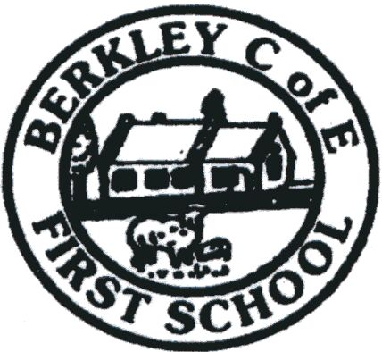
Headteacher Berkley C of E First School
Mrs S Thompson Berkley, Frome, Somerset
BA11 5JH

Tel: 01373 887390

WELCOME TO BERKLEY FIRST SCHOOL

Please find enclosed your new starter pack for your child.

Please read all enclosed information, which includes letters and forms to be completed, signed and returned to school as soon as possible.

Please keep the details for the ‘Berkley home/school agreement’ and just return the signed page.
Please ensure all the following are returned to school:

- Data Form
- Home School Agreement
- Consent Form For The Recording And Use Of Images
- Free School Meals Application Form
- Acceptable Use of ICT
- Reception ICT rules
- Nut Aware
- Routine off-site vists
- Communication Letter

There are also information letters for your attention.
Any problems please contact the school office.
Many Thanks

Sam Berryman
School Administration Assistant

