TruThfulness
h O M e s C h O O l V A l u e s

Talk TogeTher about Truthfulness
‘I promise to tell the truth, the whole truth and nothing but the truth, so help me God’
In a court of law a witness swears an oath on the Bible or another sacred text, but sometimes in everyday life people find it more difficult to be truthful.
Talk together about occasions when complete honesty could cause trouble or be hurtful. for example:
- When a member of your family asks you if you like their new shoes
- When telling the truth will get your friend into trouble
- When someone asks what you are thinking but the answer would hurt their feelings
Think TogeTher
Words of Wisdom
“To be truthful with others, you must first be truthful with yourself”
Anon

Quiz
This term we will be focussing in school on the value
TruThfulness. We hope your family will find these ideas helpful as you explore the value and have fun together.

read TogeTher…
A Day That Changed Everything
It began just as any other day.
Peter the fisherman was mending his nets as he always did.
But then Peter met Jesus. On that ordinary day his life was changed for ever.
Peter was to actually see Jesus heal people who were ill, make blind people see again, and turn 5 loaves and 2 fish into a feast for 5000!
Peter became Jesus’ follower and friend. “I will do anything for you” he said to Jesus. “Just say the word!”
“One day you will tell people you never knew me” said Jesus, “and then a cock will crow.”
“no” shouted Peter “never, never, never!” sure enough, life for Jesus did become difficult - difficult and dangerous.
The day came when Jesus was on trial for his very life. he needed his friend to stand by him. But Peter said “I don’t know him, I never knew him, I never saw him before.”
And at the end of the day a cock crowed.....just as Jesus had said it would.
Jesus was sentenced to death and crucified, even though he had done nothing wrong.
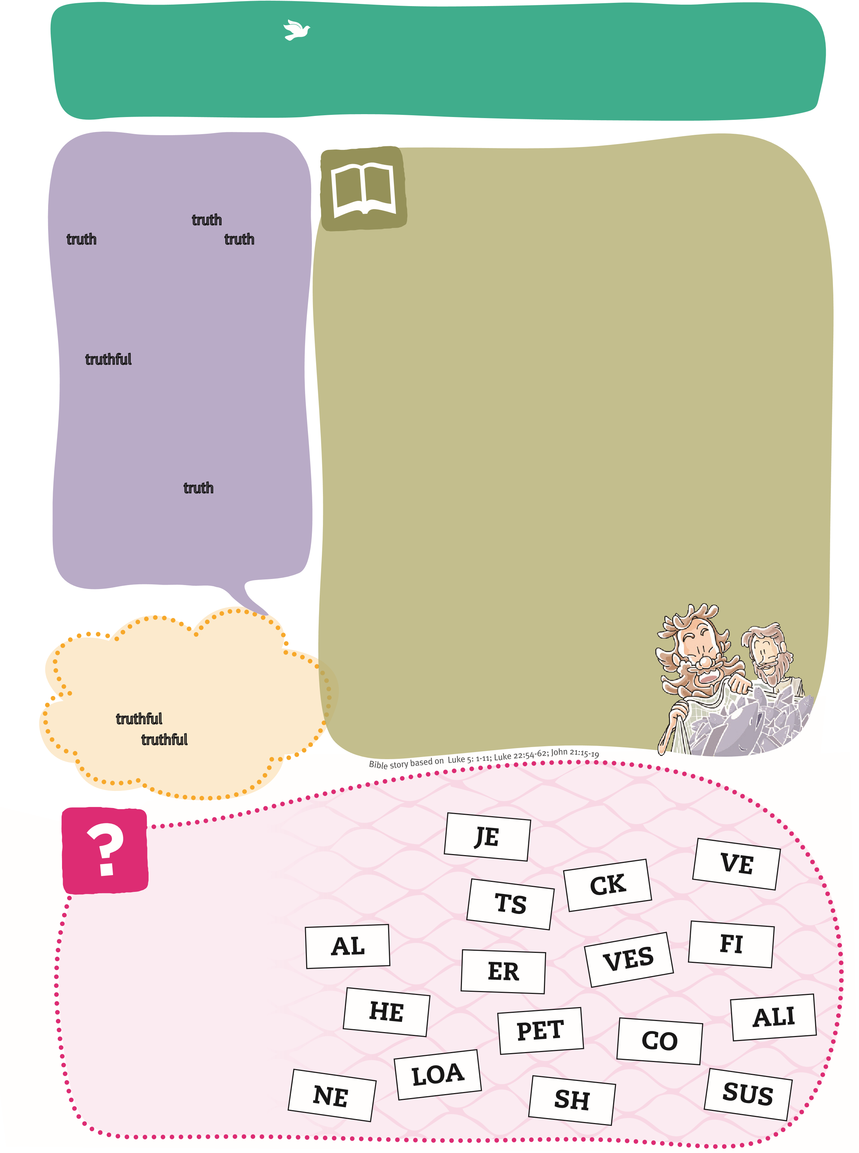
But death could not defeat God’s son! Three days later Jesus was alive again and went to find his friend, not to blame him but to forgive him. It was a new day and Peter had another chance. everything was different!

Words in the Fishing Net
Pair letters from the net together to make words from the story. You could colour matching halves... for answers, see reverse.
